Mallu Sravana Sandhya Assessment-12 16/12/2023

NESTED FUNCTIONS-functions inside another function

ANONYMOUS FUNCTIONS:functions without function name lambda keyword is used to create these functions

RETURN :return keyword is used to give the result of the function and go back to the function call

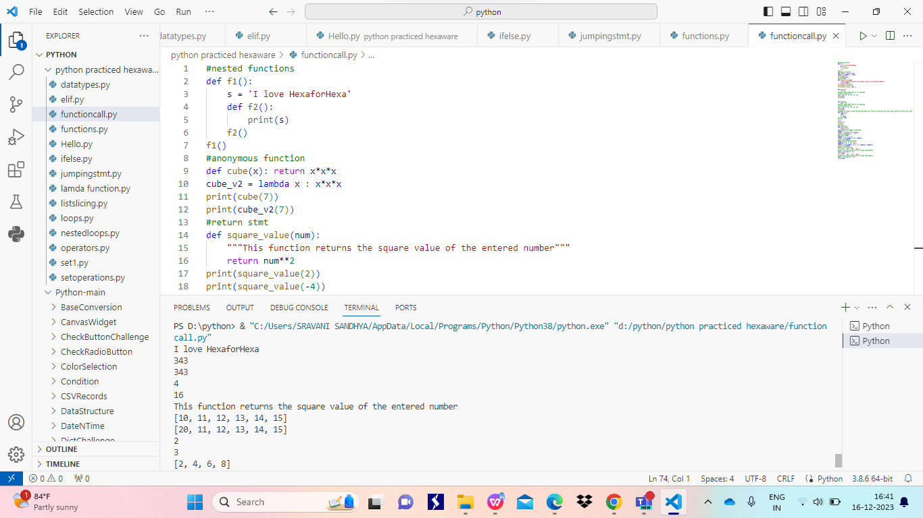

#changes in values inside the function does not reflect on outside until and unless function returns the value

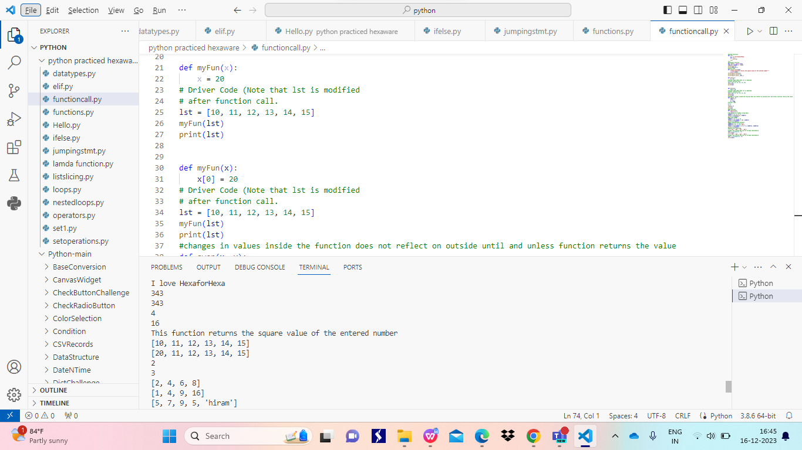

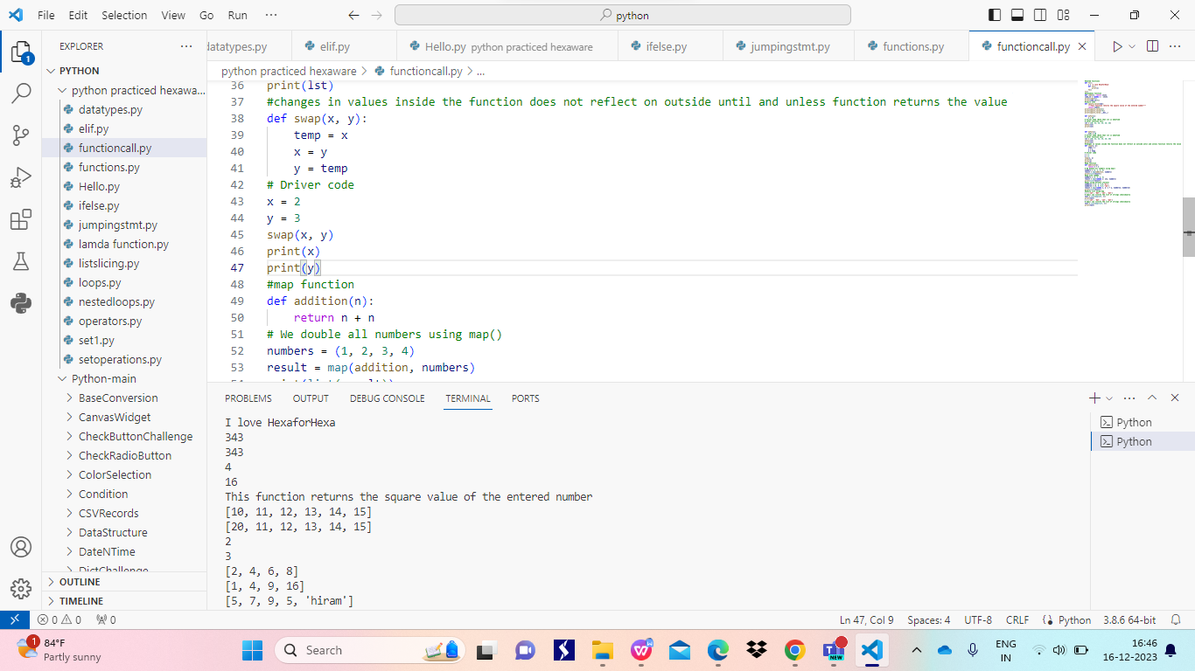

MAP FUNCTION-repetedly executes the function using iterator

Syntax:

map(func,iterator)

Map always returns a list of results

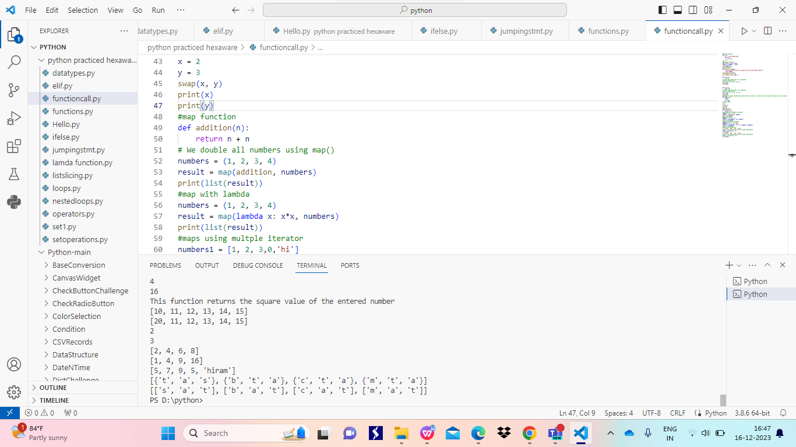

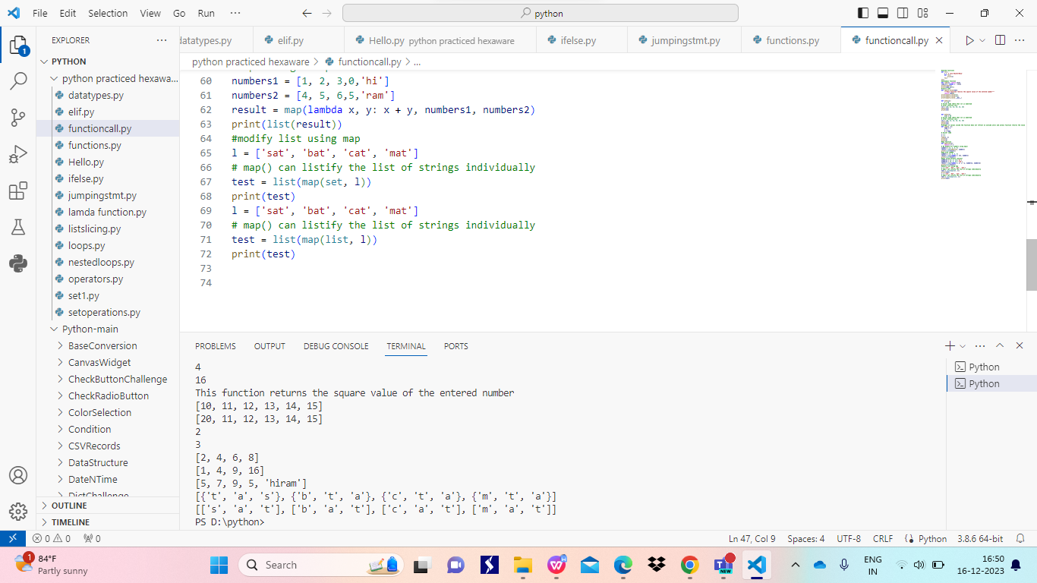

LAMBDA FUNCTIONS: these are also known as anonymous functions.

They are similar to functions with small difference

They must have return type, can only contains atmost one expression but many number of variables

It reduces the readability

